**University of Westminster** Computer Science & Software Engineering

|  |  |
| --- | --- |
| **5COSC002W DATABASE SYSTEMS COURSEWORK (2020/2021)** | |
| **Module leader** | **Francois ROUBERT** |
| **Unit** | **Database Systems Coursework – INDIVIDUAL COURSEWORK** |
| **Weighting:** | **60%** |
| **Qualifying mark** | **30%** |
| **Description** | **Produce a conceptual data model & a logical data model following given specs. Write SQL statements to complete specific tasks. Produce a supporting report.** |
| **Learning Outcomes Covered in this Assignment:** | * LO1 design a data model using standard EERM constructs and convert this model into a relational database schema; * LO2 use UML notations to produce a design that would encompass procedural aspects of a data management system; * LO3 apply normalisation up to BCNF to a set of relational database tables; * LO5 produce SQL queries to retrieve information from one or more tables; * LO6 write a simple application program in a procedural language that interacts with a relational database. |
| **Handed Out:** | **End of September 2020** |
| **DUE DATE** | * **MONDAY 19 OCTOBER 2020 at 13:00:00** – **Part A**      * **MONDAY 23 NOVEMBER 2020 at 13:00:00** – **Part A + Part B** |
| **DELIVERABLES** | * **MONDAY 19 OCT 2020 at 13:00:00** – **Intermediary** **Report: Part A**   Report in PDF format, font Calibri size 11   * + *1 cover page for part A, student details & tutorial group attended*   + *1 side featuring conceptual ERD*   + *4 data dictionary tables supporting conceptual ERD*      * **MONDAY 23 NOV 2020 at 13:00:00 – FINAL REPORT:** **Part A + Part B**   Report in PDF format, font Calibri size 11   * + *1 cover page for part A+B, student details & tutorial group attended*   + *1 side featuring conceptual ERD*   + *4 data dictionary tables supporting conceptual ERD*   + *1 side featuring logical ERD*   + *2-3 sides featuring step-by-step guide for logical ERD*   + *SQL code (DDL) for creating and populating 3 tables and screenshots of contents and structures of the tables*   + *SQL code (DML) for querying 3 tables and screenshots of the outputs of the query* |
| **SUBMISSION** | **Online in ‘2020-2021 SUBMIT COURSEWORK’ section on Blackboard.** |
| **Type of Feedback and Due Date:** | **PART A**: verbal formative feedback on conceptual ERD in online tutorial following submission (week 5), failure to attend will restrict opportunity for feedback.  **PART A + B**: online feedback and marks 15 working days (3 weeks) after the submission deadline.  **All marks provisional until formally agreed by Assessment Board**. |
| **BCS Accreditation Criteria** | 2.1.1 Knowledge and understanding of facts, concepts, principles & theories  2.1.2 Use of such knowledge in modelling and design  2.2.1 Specify, design or construct computer-based systems  2.3.2 Development of general transferable skills  3.1.3 Knowledge of systems architecture  3.2.1 Specify, deploy, verify and maintain information systems |

***Assessment regulations***

For detailed information regarding University Assessment Regulations on how you are assessed, penalties and late submissions, what constitutes plagiarism etc. please refer to the following website**:**

[**http://www.westminster.ac.uk/study/current-students/resources/academic-regulations**](http://www.westminster.ac.uk/study/current-students/resources/academic-regulations)

***Penalty for Late Submission***

**If you submit your coursework late but within 24 hours or one working day of the specified deadline, 10 marks will be deducted from the final mark, as a penalty for late submission, except for work which obtains a mark in the range 40 – 49%, in which case the mark will be capped at the pass mark (40%). If you submit your coursework more than 24 hours or more than one working day after the specified deadline you will be given a mark of zero for the work in question unless a claim of Mitigating Circumstances has been submitted and accepted as valid.**

**It is recognised that on occasion, illness or a personal crisis can mean that you fail to submit a piece of work on time. In such cases you must inform the Campus Office in writing on a mitigating circumstances form, giving the reason for your late or non-submission. You must provide relevant documentary evidence with the form. This information will be reported to the relevant Assessment Board that will decide whether the mark of zero shall stand. For more detailed information regarding University Assessment Regulations, please refer to the following website:**

[**http://www.westminster.ac.uk/study/current-students/resources/academic-regulations**](http://www.westminster.ac.uk/study/current-students/resources/academic-regulations)

# Coursework Specifications Part A: Conceptual ERD

# [35 Marks]

## Part A Project Brief: FOODTOOYOO

FOODTOOYOO is a fast grocery delivery service based in London. FOODTOOYOO allows signed up members to have groceries from a number of registered retailing stores rapidly delivered at home, on the same day or on the following day. The idea was initiated during the COVID-19 lockdown that was put in place in UK from March to June 2020 when access to groceries became challenging for many households.

Several grocery stores of varying sizes take part in the FOODTOOYOO scheme and offer a wide range of products which are unique to each store (this means specifically that for this service, stores are only able to offer a selection of their own branded products). For every store, it is critical to carefully record the details of the specific products they offer, such as the name, description, additional information, price, and stock level. Some products are perishable (most products, in fact) but not all are. For perishable products, it is essential to store the expiry date. Perishable products can either be food products or drink products. For perishable products of food type, it is important to record a description of ingredients and allergy information, while for perishable products of drink type, the sugar content and the alcohol by volume need to be stored (if the drink contains alcohol).

Registered members can create various FOODTOOYOU shopping baskets with different stores. They need to create a separate basket for every store from which they are willing to purchase products (as products on retail are specific to every store). They can place any products they are interested in buying from a store in a shopping basket and keep updating the content of their baskets (quantity and products ordered) as much as they wish. When their basket is complete, members can confirm and finalise their order based on this basket and request a delivery for this order. The delivery date and time will be automatically determined by FOODTOOYOO and will be within 2 hours of the order (unless the order has been placed late at night, in which case it will be delivered as early as possible the following morning). The date, time, and status (e.g. pending, confirmed, in process, delivered, etc.) of the delivery needs to be carefully recorded. For every confirmed order, members need to make a payment. FOODTOOYOO accepts two main types of payments: payments by cards (the card security code is required) and mobile payments using a smart phone (a mobile wallet is required).

To get the groceries to the homes of the registered members, FOODTOOYOO hires a significant number of drivers. Key information for these drivers needs to be captured (e.g. personal details, contact details, etc.) Drivers need to collect confirmed orders (i.e. the products selected as part of orders that have been finalised and paid) to then deliver them to members’ home addresses. The details of the collections of confirmed orders need to be recorded thoroughly, like the date and time of the collection and its status (e.g. pending, confirmed, in process, delivered, etc.). Collections can handle multiple orders. There are also two types of drivers: four-wheel drivers (who drives cars or vans) and two-wheel drivers (who typically use mopeds or bicycles). Two-wheel drivers can only make small collections as they are limited by the volume that their vehicles can carry. This means they can only handle small collections (for single orders or a few orders of limited sizes). On the other hand, four-wheel drivers will be only used to make larger collections (i.e. for a greater number of larger orders), as their vehicles allow them to carry larger quantities.

## Part A Questions

You have been hired by FOODTOOYOU as a database architect to undertake a database project to support the data needs of the company. Your job in this first part is to produce a high-quality **CONCEPTUAL ENTITY RELATIONSHIP DIAGRAM (ERD)** and to produce a **data dictionary** to document and support your model.

### Prefix the names of all entities and attributes with your id number starting with w.

1. Produce a complete **CONCEPTUAL ERD** for FOODTOOYOU.

It needs to include all the **entities**, **relationships**, **multiplicities**, **attributes** and **primary keys** that you have identified. It should be easy to read and needs to fit on one page of the report.

1. Create a **data dictionary** to document how you identified the **entities** for FOODTOOYOU. To achieve this, fill in the 2 tables below to summarise and briefly explain the meaning of each entity.

|  |  |
| --- | --- |
| *Entity name* | *Description* |
|  |  |
|  |  |
|  |  |

|  |  |  |
| --- | --- | --- |
| *General entity* | *Specialised entity* | *Explanation* |
|  |  |  |
|  |  |  |
|  |  |  |

*For more information, please refer to page 510 of the 6th edition of the Connolly’s textbook.*

1. Create a **data dictionary** to document how you identified the **relationships** and **multiplicities** for FOODTOOYOU. To achieve this, fill in the table below to summarise and justify the multiplicities for each relationship.

|  |  |  |  |  |  |
| --- | --- | --- | --- | --- | --- |
| *Entity name* | *Multiplicity* | *Relationship* | *Multiplicity* | *Entity name* | *Justifications for the multiplicity*  *(4 statements for each relationship)* |
|  |  |  |  |  |  |
|  |
|  |
|  |
|  |  |  |  |  |  |
|  |
|  |
|  |

*For more information, please refer to page 513 of the 6th edition of the Connolly’s textbook.*

Create your own separate table if you identify complex relationships to identify the entities involved and provide justifications.

1. Create a **data dictionary** to document how you identified the **attributes** and **primary keys** for each entity for FOODTOOYOU. To achieve this, fill in the table below to summarise and explain the meaning of each attribute and primary key.

|  |  |  |
| --- | --- | --- |
| *Entity name* | *Attributes for this entity (include PK)* | *Justification* |
|  |  |  |
|  |  |  |
|  |  |  |

*For more information, please refer to page 516 of the 6th edition of the Connolly’s textbook.*

 **Interactive FAQ**

To provide you with the support you may require as a Database Architect and answer any questions you may have about the FOODTOOYOU brief, an interactive FAQ is offered. This allows you to ask specific targeted questions to the FOODTOOYOU Managing Directors about the FOODTOOYOU business so that to improve and refine your conceptual ERD and for these questions and their answers to be shared with the entire class. The interactive FAQ is available as a discussion board on the module site on Blackboard.

## Part A Marks Allocation

**Part A** will be marked based on the following marking criteria:

|  |  |
| --- | --- |
| Criteria | Mark per component |
| **Correct identification of entities + data dictionary tables** | **10** |
| **Correct identification of relationships + data dictionary table** | **10** |
| **Correct identification of multiplicities + data dictionary table** | **10** |
| **Correct identification of attributes and primary keys + table** | **05** |

**PART A TOTAL 35**

# Coursework Specifications Part B: Logical ERD & SQL [65 Marks]

## Part B Project Brief: Futuro

Futuro is the careers and professional development service offered by the University of Westmino. Futuro employs several career consultants to provide guidance and advice to the students who use the service to find employment opportunities. Companies propose many offers of employment that can be of interest to students. Students can apply to these offers of employment e.g. graduate scheme, jobs and placements. To assist the students with their applications, career consultants at Futuro organise support sessions to help them with their application forms, CVs and cover letters. Futuro career consultants also organise a number of events to showcase jobs and graduate schemes.

## Part B Questions

You have been hired by Futuro as a database architect to undertake a database project to support the data needs of the firm. In this second part, you are given a conceptual data model for Futuro (**figure 1**) and your first goal is to **map it** onto a high-quality **LOGICAL ENTITY RELATIONALHIP DIAGRAM (ERD)** to logically represent how the key business data needs can be organised as a set of interrelated tables that can then be implemented. These tables need to be interconnected according to the strict rules of the relational model to be implementable. You also have to write SQL queries to retrieve specific data.

### Prefix the names of all tables and attributes/columns with your id number starting with w.

1. Produce a complete **LOGICAL ERD** for Futuro (mapped out from the Conceptual ERD given on **figure 1**). This needs to include all the **correct tables, relationships, multiplicity constraints, attributes, primary keys** and **foreign keys**.

This needs to fit on one page of the report.

1. Provide a **step-by-step guide** explaining how you produced the Futuro **logical ERD** i.e. how you **mapped** the Futuro conceptual ERD (figure 1) into a full **logical relational schema**. To achieve this, write a series of numbered **bullet points** (e.g. [1], [2], [3], etc.) to explain how and in which order you applied the **10 rules of the Logical Data Modelling Methodology** (see Lecture 04 and Lecture 05) to convert the given Conceptual ERD into a Logical ERD. This needs to fit on no more than three pages of the report

1. Write some SQL code to **create the** **Company**, **Staff and Offer tables** in the MySQL RDBMS. Also **insert 3 records in the Company table,** **4 records in the Staff table and 5 records in the Offer table.**

Ensure that you follow the instructions below:

* + All 3 tables should have Primary Keys and possibly Foreign Keys, if they need them.
  + No field should be left empty.
  + Remember to prefix the names of the tables and columns with your id number starting with w.
  + Include the **SQL code** used to create both tables and **screenshots of the structure of the tables**.
  + Include the **SQL code** used to insert the 3 records in the Company table and a **screenshot of the content of the Company table**.
  + Include the **SQL code** used to insert the 4 records in the Staff table and a **screenshot of the content of the Staff table**.
  + Include the **SQL code** used to insert the 5 records in the Offer table and a **screenshot of the content of the Offer table**.

* + The screenshots should clearly show your student id numbers (in the names and of the table and attributes and also right above the tabs for the content and the structure of the table in PHPMYAdmin).

1. Write a SQL query to retrieve a list of company codes and company names and for each company the number of staff that they employ, making sure that the header shows the number of employees in each company as “Number of staff”.

Ensure that you followthe instructions below:

* + Include the **SQL code** used for this query (with tables and columns prefixed with your id number starting with w).
  + Show a screenshot of the output produced by your query.
  + The screenshot should clearly show your student id numbers (in the names and of the table and attributes and also right above the tabs for the structures of the table and on the left hand-side in PHPMYAdmin, **see figure 2**).

1. Write a SQL query that displays a list of company names along the names and positions of staff they employ and the names and descriptions of the offers they propose.

Ensure that you followthe instructions below:

* + Include the **SQL code** used for this query (with tables and columns prefixed with your id number starting with w).
  + Show a screenshot of the output produced by your query.
  + The screenshot should clearly show your student id numbers (in the names and of the table and attributes and also right above the tabs for the structures of the table and on the left hand-side in PHPMYAdmin, **see figure 2**).

## Part B Marks Allocation

**Part B** will be marked based on the following marking criteria:

|  |  |
| --- | --- |
| Criteria | Mark per component |
| **Correct mapping of specialisations + sound explanation** | **12** |
| **Correct mapping of relationship (M:M) + sound explanation** | **16** |
| **Correct mapping of simple relationships (1:M & 1:1) + sound explanation** | **07** |
| **Correct SQL Data Definition Language (DDL) query to create tables and insert records** | **15** |
| **Correct SQL Data Definition Language (DML) query to insert records** | **15** |

**PART B TOTAL 65**

___________________________________________________________________________________

**Key Requirements for the entire coursework**

* Only **UML notations** are accepted, as introduced in this module.

* You need to **prefix** all your entities and attributes with “w + the 7 digits of your ID number” as provided by the University.

For example, if my name is Francois Roubert and my ID number is w1234567, when I identify the entity “Module” and its attributes “moduleCode”, “moduleName” and “moduleType”, I will have to represent it this way

|  |
| --- |
| w1234567_Module |
| w1234567_moduleCode{PK}w1234567_moduleName w1234567_moduleType |

_____________________________________________________________________________________

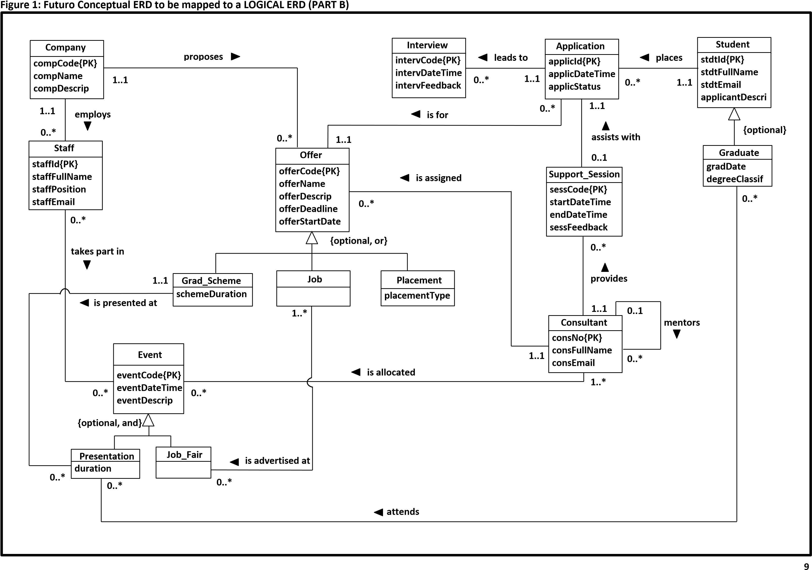

**10**

**Figure**

**2**

**:**

**screenshot**

**s**

**for the**

**SQL questions**

**in part B questions 7) 8)**

**and 9)**

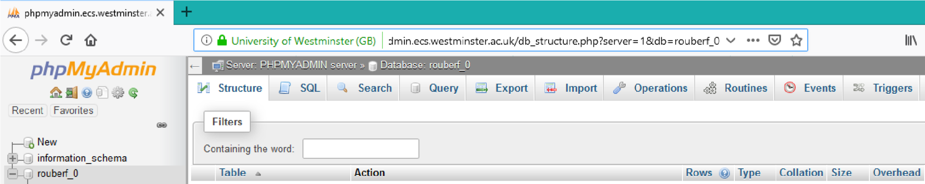

**YOUR**

**ID NUMBER STARTING WITH W**